/*

Author: Connie Deng

Course: CSCI-136

Instructor: Genady Maryash

Assignment: Homework 3.6, e.g., Lab1C

Homework 3.6

*/

**Self-Check**

Q1:

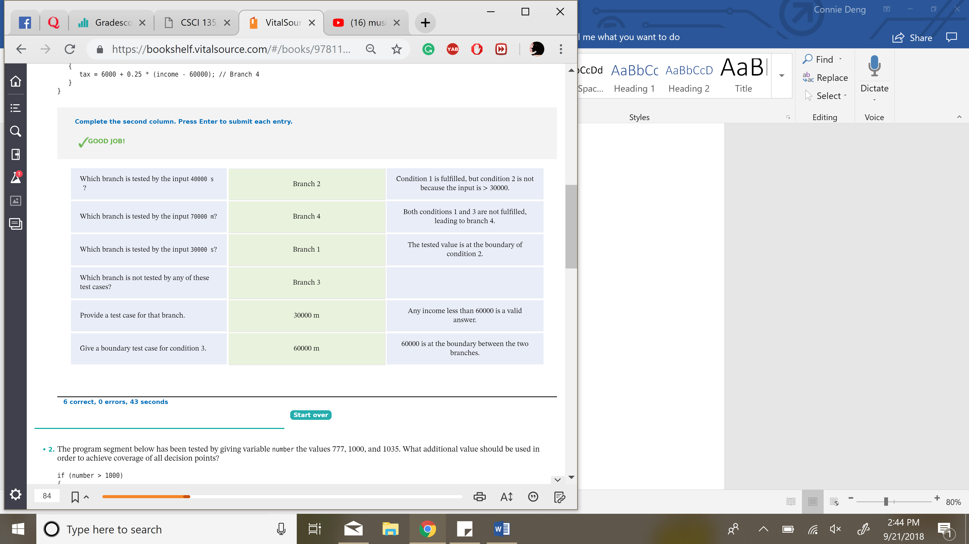

Q5)

